About Page

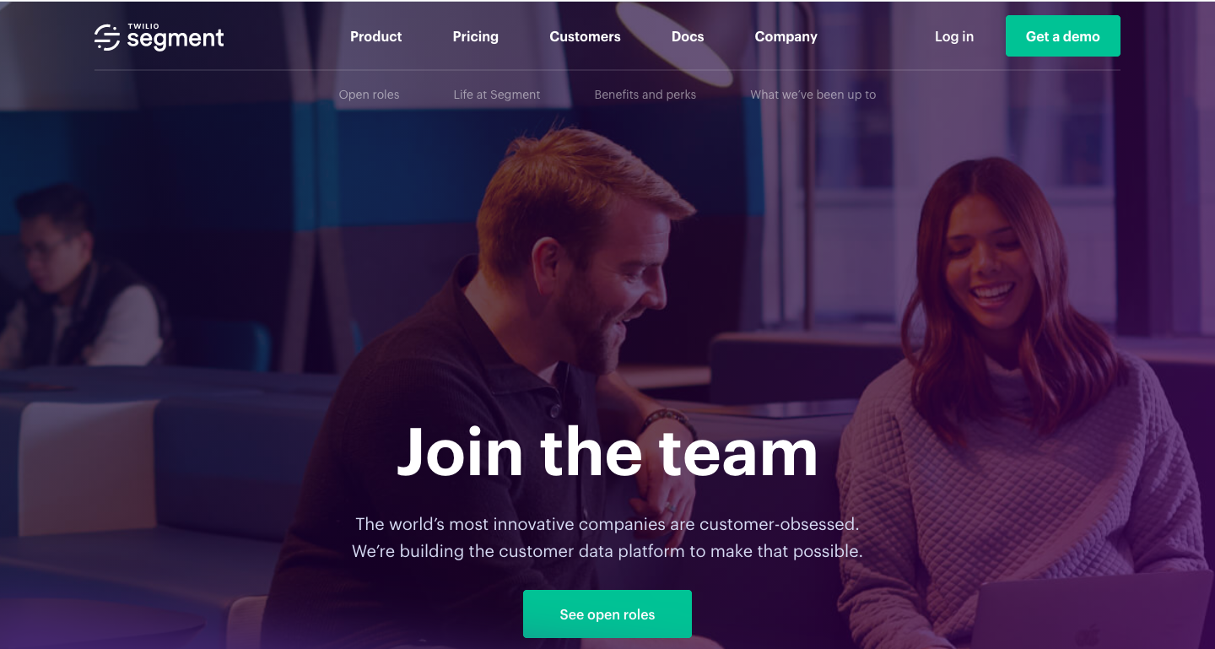

**Our Story**

When the world changes, business changes too. The world’s most innovative companies are customer-obsessed.

We’re building the multichannel marketing application to make that possible.

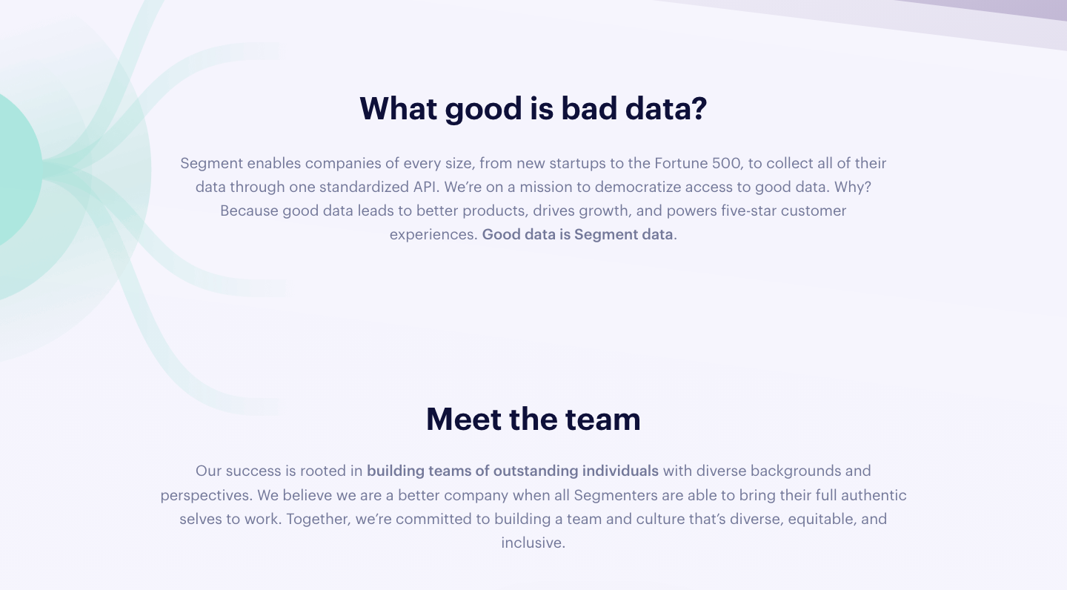  
  
“Botsuite enables companies of every size, from new startups to the Fortune 500, to market their brand through one single platform. From lead capturing to customer acquisition, from interaction to follow-up and conversion, Botsuite powers five-star customer experiences and drives growth.”

Workspace pics (4*4)

**Meet The Team**

The team who is working to make the world a better place. Our success is rooted in building teams of extraordinary individuals with diverse skill sets, knowledge base, perspectives and background. Together, we are committed to build a culture and team that’s equitable, diverse and inclusive.

Great power comes with great productivity.

Team Pics



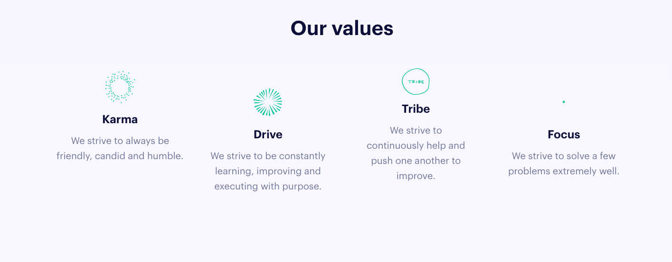

Our Values

When people love what they do, what they do is amazing.

1. Karma & Integrity

Be humble, candid and friendly. Integrity is the core and key asset of our company which helps partners, customers and employees prosper.

1. Drive

Constantly learn, improve, innovate and execute. Challenge yourself everyday & see how you can add more value to your customer’s business.

1. Accountability

Every employee takes the responsibility and accountable for the actions during the task execution. This increases the competition, passion and leads to healthy team spirit.

1. Focus

Do small but do it well. Build relationships with customers and add value to their business by delivering outstanding experience and it can be achieved only via focus.

## **Our offices**

Headquarters are in New Delhi, but we have four other offices, including in Sydney, Toronto, California, London

Reference for map:-

<https://segment.com/careers/?ref=nav>